Name:Mustafa Nasikwala

Roll:1

Div:F

BI Lab Assignment 4

**Title :Create a report using i) Crosstab ii) Charts iii) Graphs**

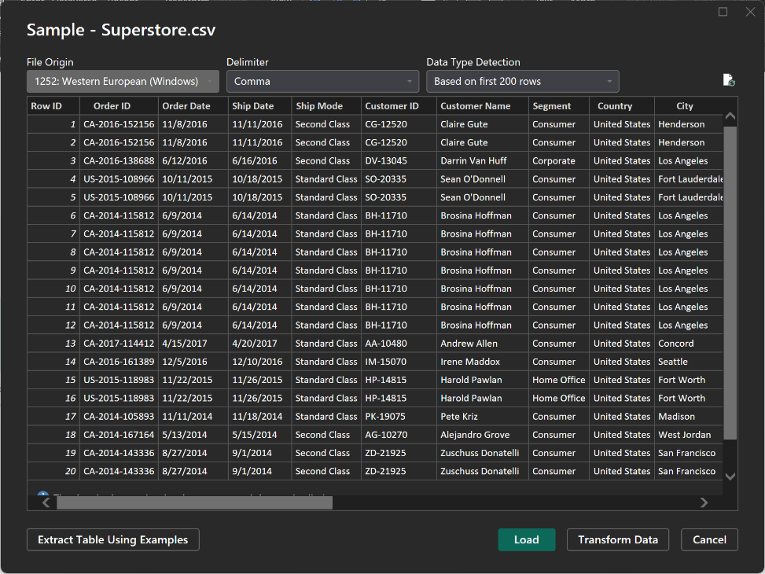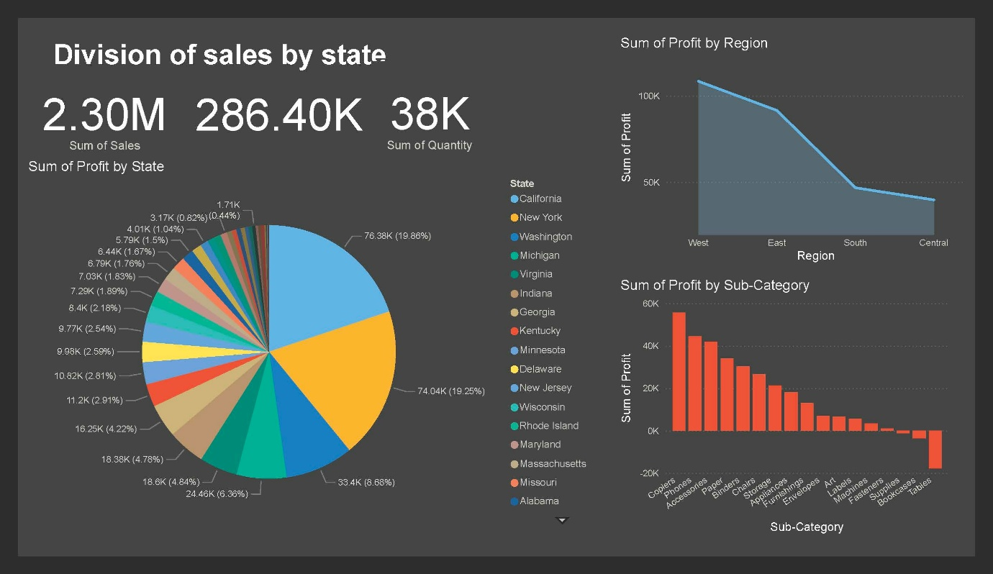

**Creating and Customizing Authoring Reports in Power BI**

**Analysing Report**

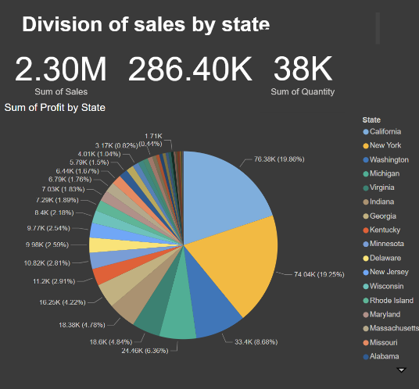**1]**  **Pie Chart: Division of Profit and Quantity of Product Sold per State**

This pie chart offers a visual representation of how profits and quantities of products sold are distributed across different states. It also includes the total sum of sales for all states. This can help identify:

* **High-Performing States**: States contributing the most to profits and product sales.
* **Underperforming States**: States with lower sales and profits, indicating potential areas for improvement or targeted marketing strategies.
* **Sales Distribution**: Understanding which states are the largest and smallest markets, aiding in resource allocation and supply chain planning.

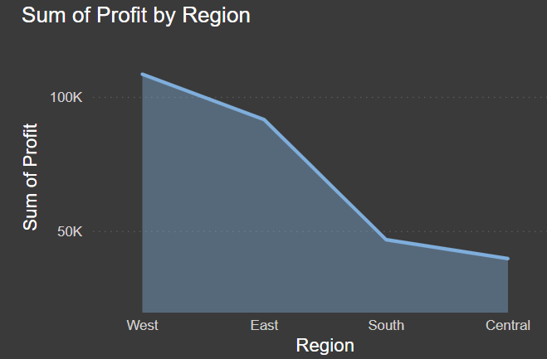2] **Area Chart: Division of Profit by Region of Country**

This area chart shows the division of profit across various regions of the country. It is particularly useful for:

**Trend Analysis**: Observing trends and patterns in profitability over time across different regions.

* **Regional Comparison**: Comparing profits between regions to identify which regions are performing better or worse.
* **Seasonal Variations**: Detecting any seasonal variations in profit by region, which can inform marketing and sales strategies.

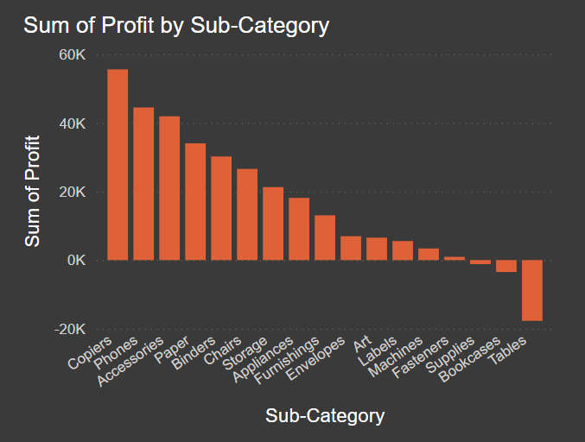

3]**Stacked Column Chart: Profit and Losses Division by Category of Popular Products**

This stacked column chart illustrates the division of profits and losses by categories of popular products. Key insights include:

* **Product Performance**: Identifying which product categories are generating the most profit and which are incurring losses.
* **Category Comparison**: Comparing different categories to understand their contribution to overall financial performance.
* **Focus Areas**: Highlighting categories that need more attention, either to boost sales or to reduce losses, guiding strategic decisions in product development and marketing.

**Introduction**

Power BI is a powerful business analytics service that enables users to visualize and share insights from their data. Creating and customizing authoring reports in Power BI allows users to tailor their reports to meet specific business needs and enhance data-driven decision-making.

**Steps to Create an Authoring Report**

1. **Install Power BI Desktop**: Download and install Power BI Desktop from the Microsoft Store or the official website.
2. **Connect to Data Sources**: Use Power BI Desktop to connect to various data sources such as Excel files, databases, and online services.
3. **Transform Data**: Utilize Power Query to shape and clean the data, including renaming columns, combining columns, and handling null values.
4. **Load Data into the Data Model**: Load the transformed data into the data model, creating relationships between tables and managing data types.
5. **Create Measures with DAX**: Use Data Analysis Expressions (DAX) to create measures for performing calculations on the data.
6. **Design Visuals**: Drag and drop fields onto the report canvas to create various types of visuals such as bar charts, line charts, and custom visuals.
7. **Publish the Report**: Once the report is complete, publish it to the Power BI Service for sharing and collaboration.

**Customizing Authoring Reports**

1. **Custom Navigation**: Implement custom navigation schemes to enhance user experience, including left and bottom navigation options.
2. **Custom Bookmarks**: Create and manage custom bookmarks to save report states and enable easy navigation.
3. **Custom Layouts**: Design custom layouts for embedded reports, allowing dynamic positioning and resizing of visuals based on user preferences.
4. **Self-Service Authoring**: Enable self-service authoring capabilities for users, allowing them to create and modify reports directly within the application.
5. **Save and Save As Operations**: Handle save operations, including saving the report and saving as a new report with personalized settings.

**Conclusion**

Creating and customizing authoring reports in Power BI empowers users to create tailored reports that meet specific business needs. By leveraging Power BI's robust features and customization options, users can enhance data visualization, create dynamic and interactive reports, and drive better decision-making. Whether through custom navigation, bookmarks, layouts, or self-service authoring capabilities, Power BI provides the tools needed to turn raw data into valuable insights and share them effectively across an organization.